Final: Lin

Here is the table can be used in step 1, step 2 and step 3
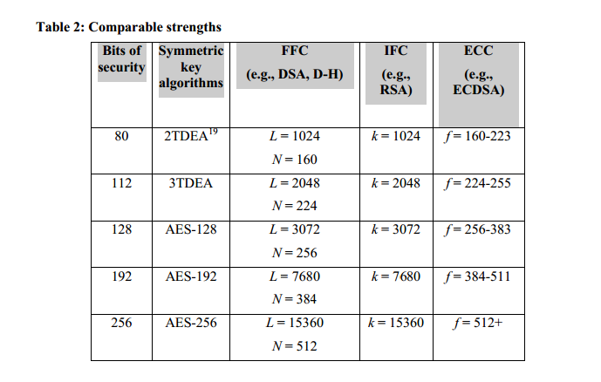
Table1
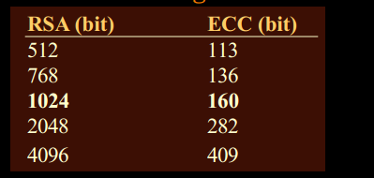
Table2
Table1 can be find in SP800-57-part1 page 63, table2.
Table2 can be find in the link:http://edge.cs.drexel.edu/regli/Classes/CS680/Papers/EC_prezentacio.pdf page12
There is also pdf in folder, it is EC_prezentacio .pdf
There is also wiki page available for that.
Here is the link:http://en.wikipedia.org/wiki/Key_size#cite_note-7
- Discuss the security strength for Project part 1 using a table.
For AES Key, the bits of security will be 128/256+12*8=224/352
For KWK, the bits of security will be 128/256+16*8 = 256/384

RSA | AES key | IV(byte) | Key wrap key | Key wrap key IV(byte) | Total
1024 | 128 | 12(GCM) | 128/256 | 16(CBC) | 80
1024 | 256 | 12(GCM) | 128/256 | 16(CBC) | 80
2048 | 128 | 12(GCM) | 128/256 | 16(CBC) | 112
2048 | 256 | 12(GCM) | 128/256 | 16(CBC) | 112
4096 | 128 | 12(GCM) | 128/256 | 16(CBC) | 192
4096 | 256 | 12(GCM) | 128/256 | 16(CBC) | 192
from the table we can convert RSA to the RSA 1024 equals to 80bits, 2048 equals to 112bits, there is no RSA4096 in the table, consider with table 2 and table 1, RSA4096 equals to 192

In step 2, we still should use the data in the table above.
For ECDH P-256,P-384,P-521,K571, their bits of strength is 128,192, 256,256+.
- Discuss the security strength for Project part 2 using a table.
Because we chose a very large nonce(512bytes) so to using Shared Secrete to crack the AES Key and IV is incomputable(compared to crack AES Key directly), and because KWK is generated by hashing SharedSecrete and in my program I just hashing the shared secrete 1000 times so here I assume it needs 11bits(just by trial and error, not to do pre-image or collision). So we compare the bits of strength of ECDH ,AES Key and KWK directly.
For AES Key, the bits of security will be 128/256+12*8=224/352
For KWK, the bits of security will be 128/256+16*8 = 256/384
ECDH | Private key length(byte) | Public key length(byte) | SharedSecrete length(byte) | AES | IV(byte) | Key wrap key | Key wrap key IV(byte) | Total
P-256 | 67 | 91 | 32 | 128 | 12 | 128/256 | 16 | 224
P-256 | 67 | 91 | 32 | 256 | 12 | 128/256 | 16 | 256(KWK128bit)  267(KWK256bit)
P-384 | 80 | 120 | 48 | 128 | 12 | 128/256 | 16 | 224
P-384 | 80 | 120 | 48 | 256 | 12 | 128/256 | 16 | 256(KWK128bit)  352(KWK256bit)
P-521 | 98 | 158 | 66 | 128 | 12 | 128/256 | 16 | 224
P-521 | 98 | 158 | 66 | 256 | 12 | 128/256 | 16 | 256(KWK128bit)  352(KWK256bit)
K-571 | 104 | 170 | 72 | 128 | 12 | 128/256 | 16 | 224
K-571 | 104 | 170 | 72 | 256 | 12 | 128/256 | 16 | 256(KWK128bit)  352(KWK256bit)

Notice:here is how to get the second row 267 bits for P-256.
For KWK-256bit it need 352bits to crack AES key directly. And to crack Shared Secret needs 256. As we have assumed before that to do the hashing and get KWK need 11bits compute. So 256+11 = 267bits and we can get the KWK and IV.
- Discuss the security strength for Project part 3 using a table. Create a table to include all input parameters.
For AES Key, the bits of security will be 128/256+12*8=224/352
For KWK, the bits of security will be 128/256+16*8 = 256/384

In my program the the KWK is generated by hashing MK 1000times, so does the IV. I assume it need 11bits compute. So when we crack the MK successfully, it still need 11 bits compute to crack the KWK.
MK length | Salt length | AES(DPK) | IV | Salt wrap key | Salt wrap key IV | Key wrap key | Key wrap key IV | Total
128 | 512 | 128 | 12 | 128 | 16 | 128/256 | 16 | 139
128 | 512 | 256 | 12 | 256 | 16 | 128/256 | 16 | 139
256 | 512 | 128 | 12 | 128 | 16 | 128/256 | 16 | 224
256 | 512 | 256 | 12 | 256 | 16 | 128/256 | 16 | 256/352
512 | 512 | 128 | 12 | 128 | 16 | 128/256 | 16 | 224
512 | 512 | 256 | 12 | 256 | 16 | 128/256 | 16 | 256/352
1024+ | 512 | 128 | 12 | 128 | 16 | 128/256 | 16 | 224
1024+ | 512 | 256 | 12 | 256 | 16 | 128/256 | 16 | 256/352

- Compare the ECDSA and RSA-DSA speed for signing plain.txt for the same strength.

In this step we will compare the speed of ECDSA and RSA-DSA for signing the same length text. We will test the SHA-256 and SHA-512 separately. All codes we using to test the speed are in the folder.

Here is the result for SHA-512 (left)and SHA-256(right)
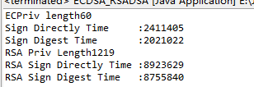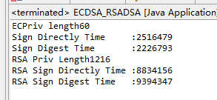
We can find that the speed for SHA-256 and SHA-512 is almost the same. And from the result we can see that the speed for signing of ECDSA is much more quickly than RSA. And what is interesting is that for ECDSA, if we sign different length of text the time will change more than that of RSA(RSA almost never changes). The time for RSA to sign the original text and the digest almost the same.(all the time is a average time fo 1000 times' running).

To confirm that we find some references from internet. Here is a table about ECDSA and RSA signature generation comparison

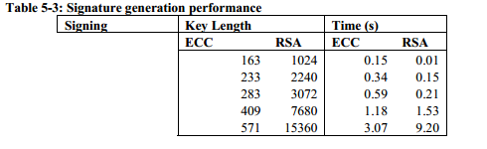

(this table is from Performance Comparison of Elliptic Curve and RSA
Digital Signatures, Nicholas Jansma, Brandon Arrendondo, April 28, 2004)
We can find in the table, in the condition of short key length, the ECC(ECDSA) do not more quickly than that of RSA, but as the key length increase(in the same security strength), the ECDSA have a advantage in the generation speed.

To test the table I find, I write another program to test that.
Here is the test result, the code is in the Appendix A. And because for the RSA 15360 bits, it seems that it will take a very long time to run, so I just have test 1024,2240,3072 and 7680 bits.

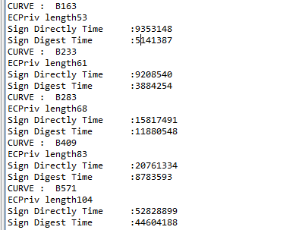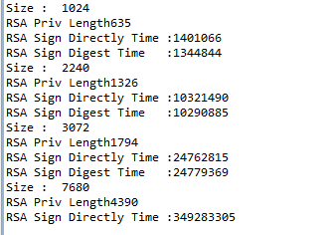
This is the curve:B163,B233,B283,B409,B571
The key size correspond to the curve can be find in the internet. Here is the link and table
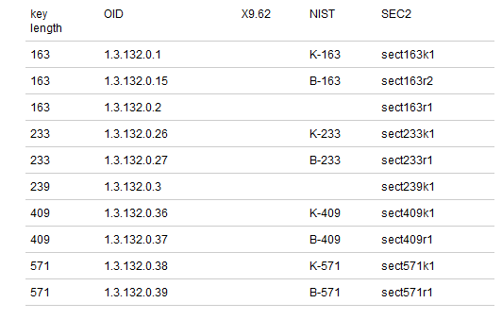
Link: http://jce.iaik.tugraz.at/sic/Products/Core-Crypto-Toolkits/ECCelerate/Supported_EC_Domain_Parameters

It may also can be find in the NIST recommendation .

So in these two figure, it just similar to the table above. For size 1024, the ECDSA curve B163 is slower than RSA, but for other curve it is quicker.

- Compare ECDH and DH speed for generating a shared secret.

We will compare different curve ECDH with the 1024 bit DH for generating a shared secrete. In order to reduce the time to run the program, we only evaluate the time of two operation, first one is the doPhase() operation and another one is the generateSecret() operation. The curves for the ECDH we test are {P192,P224,P256,P384,P521,B163,B283,B409,B571,K163,K233,K283,K409,K571}
All codes we using to test are in the folder
And here is the running result. Each one is estimated in nanosecond. Maybe the time is not accurate but the magnitude still can reflect the speed of each method.

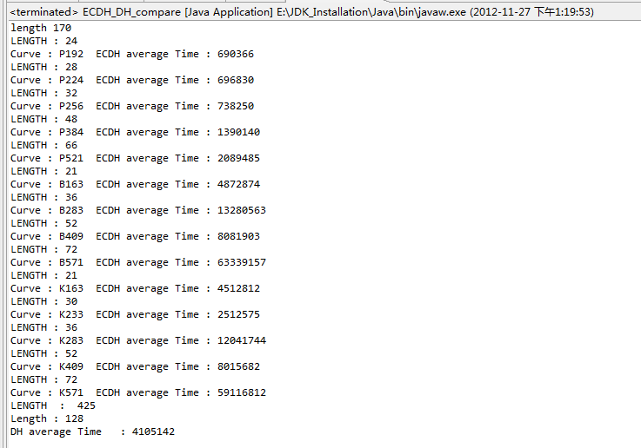

So as we can see in the capture of the result: for the P-family curve the speed of ECDH is much more quickly than the DH(1024 bits). But for some of the B-family and K-family curve (likes K-571,K283,K409,b571,etc.)it need much more time for ECDH to generate the shared. But one thing which is very different is that the length of generated shared secrete of ECDH is much more short than that of DH. And one thing do not show in the capture is that the length of public key of ECDH is also much shorter than that of DH.(The time show below is the average time of 1000 times generation)

Reference:
Link:
http://jce.iaik.tugraz.at/sic/Products/Core-Crypto-Toolkits/ECCelerate/Supported_EC_Domain_Parameters
http://nicj.net/files/performance_comparison_of_elliptic_curve_and_rsa_digital_signatures.pdf
http://edge.cs.drexel.edu/regli/Classes/CS680/Papers/EC_prezentacio.pdf
http://www.cryptopp.com/benchmarks.html

Appendix A:
public class ECDSA_RSADSA {
public static void main(String[] args){
try{
//generate ECDSA Key Pair
KeyPair ecKeyPair = null;
SecureRandom random = SecureRandom.getInstance("ECDRBG", "JsafeJCE");
String[] curve = {"P192","P224","P256","P384","P521","B163","B233","B283","B409","B571"};
MessageDigest digest = MessageDigest.getInstance("SHA-256");
byte[] Digest = new byte[256];
long average=0,start=0,end=0;
//sign plain.txt directly
byte[] message = getBytesFromFile(new File("plain.txt"));
byte[] signature;
for(int j = 0;j<curve.length;j++){
KeyPairGenerator ecKeyPairGenerator = KeyPairGenerator.getInstance("ECDSA", "JsafeJCE");
ECGenParameterSpec ecParamSpec = new ECGenParameterSpec(curve[j]);
System.out.println("CURVE : " + curve[j]);
ecKeyPairGenerator.initialize(ecParamSpec, random);
ecKeyPair = ecKeyPairGenerator.genKeyPair();
ECPublicKey pub = (ECPublicKey)ecKeyPair.getPublic();
ECPrivateKey priv = (ECPrivateKey)ecKeyPair.getPrivate();
System.out.println("ECPriv length" + priv.getEncoded().length);
Signature ecdsaSigner = null;
ecdsaSigner = Signature.getInstance("SHA256/ECDSA");

for(int i=0;i<1000;i++){
ecdsaSigner.initSign(priv);
ecdsaSigner.update(message, 0, message.length);
start = System.nanoTime();
signature = ecdsaSigner.sign();
end = System.nanoTime();
average = (end -start) + average;

}
System.out.println("Sign Directly Time :" + (average/1000));
average=0;
digest.update(message);
Digest = digest.digest();
for(int i =0;i<1000;i++){
ecdsaSigner.initSign(priv);
ecdsaSigner.update(Digest, 0, Digest.length);
start = System.nanoTime();
signature = ecdsaSigner.sign();
end = System.nanoTime();
average = average + (end-start);
}

System.out.println("Sign Digest Time :" + (average/1000));
}
Integer[] size = {1024,2240,3072,7680,15360};
KeyPairGenerator keyGen = KeyPairGenerator.getInstance("RSA");
for(int j=0;j<size.length;j++){
keyGen.initialize(size[j]);
System.out.println("Size : " + size[j]);
KeyPair keypair = keyGen.genKeyPair();
PrivateKey privateKey = keypair.getPrivate();
PublicKey publicKey = keypair.getPublic();
System.out.println("RSA Priv Length" + privateKey.getEncoded().length);
//message = getBytesFromFile(new File("plain.txt"));

S

average = 0;
Signature dsa = Signature.getInstance("SHA256withRSA");
for(int i=0; i<1000;i++){
dsa.initSign(privateKey);
dsa.update(message,0,message.length);
start = System.nanoTime();
signature= dsa.sign();
end = System.nanoTime();
average = average + (end - start);
}
System.out.println("RSA Sign Directly Time :" + average/1000);

average = 0;
for(int i=0;i<1000;i++){
dsa.initSign(privateKey);
dsa.update(Digest,0,Digest.length);
start = System.nanoTime();
signature= dsa.sign();
end = System.nanoTime();
average = average + (end - start);
}
System.out.println("RSA Sign Digest Time :" + average/1000);
}
}catch (NoSuchAlgorithmException e) {
// TODO Auto-generated catch block
e.printStackTrace();
} catch (NoSuchProviderException e) {
// TODO Auto-generated catch block
e.printStackTrace();
} catch (InvalidAlgorithmParameterException e) {
// TODO Auto-generated catch block
e.printStackTrace();
} catch (InvalidKeyException e) {

// TODO Auto-generated catch block
e.printStackTrace();
} catch (IOException e) {
// TODO Auto-generated catch block
e.printStackTrace();
} catch (SignatureException e) {
// TODO Auto-generated catch block
e.printStackTrace();
}
}
public static byte[] getBytesFromFile(File file) throws IOException {
InputStream is = new FileInputStream(file);

// Get the size of the file
long length = file.length();
if (length > Integer.MAX_VALUE) {
// File is too large
}
// Create the byte array to hold the data
byte[] bytes = new byte[(int)length];
// Read in the bytes
int offset = 0;
int numRead = 0;
while (offset < bytes.length
&& (numRead=is.read(bytes, offset, bytes.length-offset)) >= 0) {
offset += numRead;
}
// Ensure all the bytes have been read in
if (offset < bytes.length) {
throw new IOException("Could not completely read file "+file.getName());
}

// Close the input stream and return bytes
is.close();
return bytes;
}
}

